# CA-1

1)

Ans:

package com.seleinum.test.seleinum;

import org.openqa.selenium.By;

import org.openqa.selenium.WebDriver;

import org.openqa.selenium.WebElement;

import org.openqa.selenium.chrome.ChromeDriver;

import org.openqa.selenium.chrome.ChromeOptions;

import io.github.bonigarcia.wdm.WebDriverManager;

public class ca1 {

public static void main(String args[]) throws InterruptedException{

WebDriverManager.*chromedriver*().setup();

ChromeOptions co = new ChromeOptions();

co.addArguments("--remote-allow-origins=*");

WebDriver driver = new ChromeDriver(co);

driver.get("https://www.amazon.in/");

driver.manage().window().maximize();

String name = driver.getTitle();

System.***out***.println(name);

String title = "Online Shopping site in India: Shop Online for Mobiles, Books, Watches, Shoes and More - Amazon.in";

if(name.equals(title)) {

System.***out***.println("Validated Page Title");

}

driver.get("https://www.amazon.in/Boult-Audio-Wireless-Playtime-Bluetooth/dp/B0BQN2RMJF/ref=sr_1_1_sspa?keywords=realme%2Bearbuds&qid=1681292045&s=electronics&sprefix=realme%2Bear%2Celectronics%2C318&sr=1-1-spons&sp_csd=d2lkZ2V0TmFtZT1zcF9hdGY&th=1");

WebElement addToCart = driver.findElement(By.*xpath*("//*[@id=\"add-to-cart-button\"]"));

addToCart.click();

String addToCartCheck = driver.findElement(By.*xpath*("//*[@id=\"NATC_SMART_WAGON_CONF_MSG_SUCCESS\"]/span")).getText();

String addToCartMessage = "Added to Cart";

if(addToCartMessage.equals(addToCartCheck)) {

System.***out***.println("Verified adding a product to cart");

}

driver.get("https://www.amazon.in/gp/cart/view.html?ref_=nav_cart");

driver.findElement(By.*cssSelector*("[value='Delete']")).click();

driver.findElement(By.*name*("submit.addToCart")).click();

driver.get("https://www.amazon.in/gp/cart/view.html?ref_=nav_cart");

System.***out***.println("Product Updated");

driver.findElement(By.*name*("proceedToRetailCheckout")).click();

System.***out***.println("To proceed to purchase,You need to sign in");

}

}

Output:

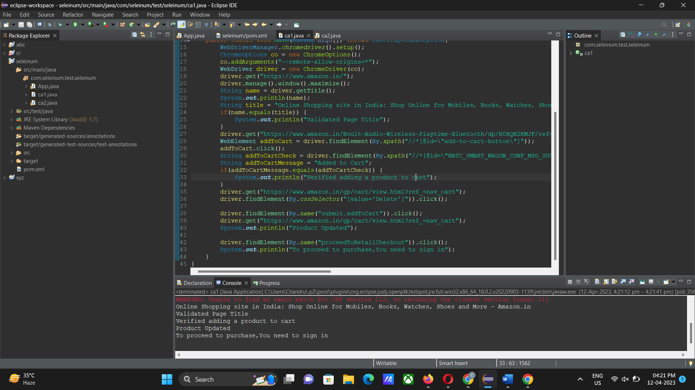

2)

Ans:

package com.seleinum.test.seleinum;

import java.util.List;

import org.openqa.selenium.By;

import org.openqa.selenium.Keys;

import org.openqa.selenium.WebDriver;

import org.openqa.selenium.WebElement;

import org.openqa.selenium.chrome.ChromeDriver;

import org.openqa.selenium.chrome.ChromeOptions;

import io.github.bonigarcia.wdm.WebDriverManager;

public class ca2 {

public static void main(String args[]) throws InterruptedException{

WebDriverManager.*chromedriver*().setup();

ChromeOptions co = new ChromeOptions();

co.addArguments("--remote-allow-origins=*");

WebDriver driver = new ChromeDriver(co);

driver.get("https://www.amazon.in/");

driver.manage().window().maximize();

String name = driver.getTitle();

System.***out***.println(name);

String title = "Online Shopping site in India: Shop Online for Mobiles, Books, Watches, Shoes and More - Amazon.in";

if(name.equals(title)) {

System.***out***.println("Validated Page Title");

}

WebElement search = driver.findElement(By.*id*("twotabsearchtextbox"));

search.sendKeys("realme earbuds");

search.sendKeys(*Keys*.***ENTER***);

String resultPage = "https://www.amazon.in/s?k=realme+earbuds&ref=nb_sb_noss";

String currentPage = driver.getCurrentUrl();

if(resultPage.equals(currentPage)) {

System.***out***.println("Product details displayed");

}

List<WebElement> list = driver.findElements(By.*xpath*("//span[@class='a-size-medium a-color-base a-text-normal']"));

int i=0;

for(WebElement link:list) {

System.***out***.println(link.getText());

i++;

if(i==10) {

break;

}

}

WebElement category = driver.findElement(By.*xpath*("//*[@id=\"n/1389401031\"]/span/a/span"));

category.click();

WebElement categoryResult = driver.findElement(By.*cssSelector*("[class='a-price-whole']"));

String categoryCurrent = categoryResult.getText();

if(categoryCurrent.equals("1,099")) {

System.***out***.println("Filter using category is accessible");

}

driver.navigate().back();

WebElement price = driver.findElement(By.*xpath*("//*[@id=\"p_36/1318503031\"]/span/a/span"));

category.click();

WebElement priceResult = driver.findElement(By.*cssSelector*("[class='a-price-whole']"));

String priceCurrent = priceResult.getText();

if(priceCurrent.equals("299")) {

System.***out***.println("Filter using price is accessible");

}

driver.navigate().back();

WebElement review = driver.findElement(By.*xpath*("//*[@id=\"p_72/1318476031\"]/span/a/section/i"));

category.click();

WebElement reviewResult = driver.findElement(By.*cssSelector*("[class='a-price-whole']"));

String reviewCurrent = reviewResult.getText();

if(reviewCurrent.equals("389")) {

System.***out***.println("Filter using review is accessible");

}

}

}

Output:

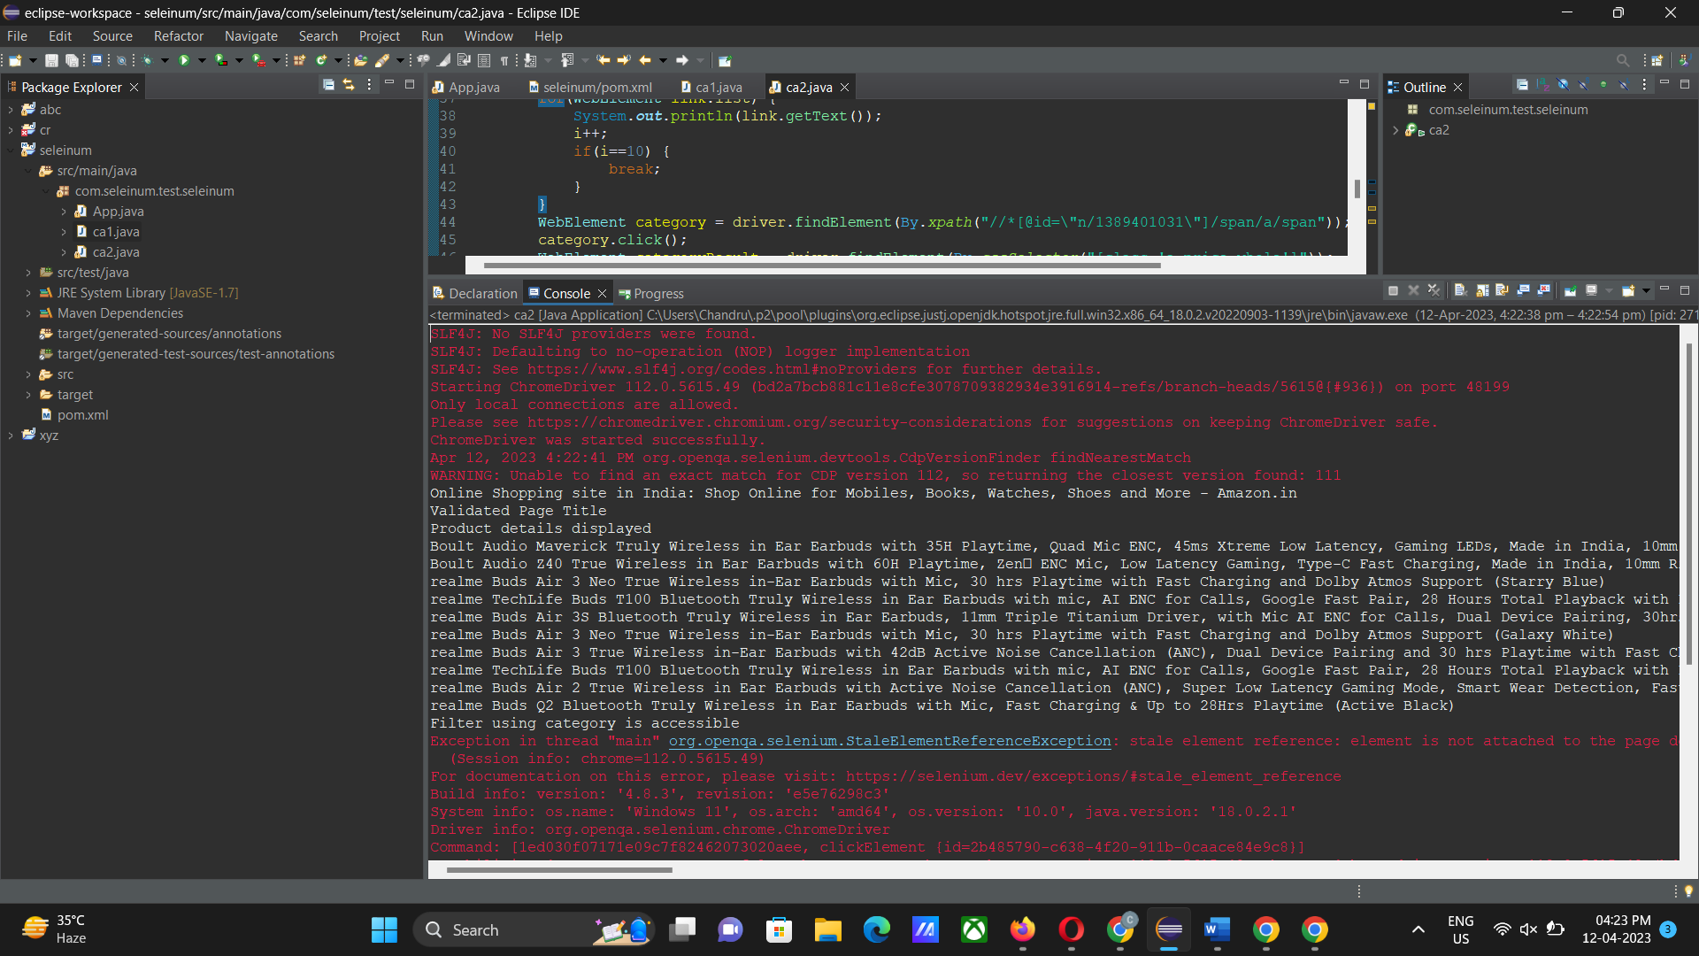

3)

Ans:

package com.seleinum.test.seleinum;

import org.openqa.selenium.By;

import org.openqa.selenium.Keys;

import org.openqa.selenium.WebDriver;

import org.openqa.selenium.chrome.ChromeDriver;

import org.openqa.selenium.chrome.ChromeOptions;

import io.github.bonigarcia.wdm.WebDriverManager;

public class ca3 {

public static void main(String args[]) throws InterruptedException{

WebDriverManager.*chromedriver*().setup();

ChromeOptions co = new ChromeOptions();

co.addArguments("--remote-allow-origins=*");

WebDriver driver = new ChromeDriver(co);

driver.get("https://www.amazon.in/ref=nav_logo");

driver.manage().window().maximize();

String name = driver.getTitle();

System.***out***.println(name);

String title = "Online Shopping site in India: Shop Online for Mobiles, Books, Watches, Shoes and More - Amazon.in";

if(name.equals(title)) {

System.***out***.println("Validated Page Title");

}

driver.findElement(By.*id*("nav-link-accountList")).click();

driver.findElement(By.*id*("ap_email")).sendKeys("9345839752");

driver.findElement(By.*id*("ap_email")).sendKeys(*Keys*.***ENTER***);

driver.findElement(By.*id*("ap_password")).sendKeys("9345839752");

driver.findElement(By.*id*("ap_password")).sendKeys(*Keys*.***ENTER***);

Thread.*sleep*(2000);

String name1=driver.findElement(By.*id*("nav-link-accountList-nav-line-1")).getText();

if(name1.equals("Hello, Chandru")) {

System.***out***.println("Successfully, signed in as Chandru");

}else {

System.***out***.println("Sign in failed");

}

System.***out***.println("Testing Ended");

driver.quit();

}

}

Output:

